

**Sri Lanka Institute of Advanced**

**Technological Education**

**(**

**SLIATE**

**)**

**Higher National Diploma in Information Technology**

**Interim report**

**Individual**

**TITLE**

**ONLINE VOTEING MANAGEMENT SYSTEM.**

**Reg.No:**

**BAT/IT/2018/FT/0074**

**Name:**

**S.SANUSANTH**

**SUPERVISD BY:-**

**MR.T. Mathanaruban**

Table of Contents

1. INTRODUCTION……………………………………………………..………4

**1.1.** **Identification of the problems……………………...…………………..….5**

**1.2.** **Goals and Objectives………………………………..………………..……6**

**1.3.** **Scope……………………………………………………………………….** **6**

2. BACKGROUND OF PROJECT…………………………………………….7

3. SYSTEM ANALYSIS………………………………………………………...8

**3.1.** **Fact finding Techniques…………………………………………………..8**

**3.2.** **Software Requirement Specification……………………………………..9**

**3.2.1.**  **System Requirements…………………………………………………9**

**3.2.1.1. Functional Requirements………………………………………9**

**3.2.1.2.** **Non Functional Requirements…………………………………**9

**3.2.2.** **Software and Hardware Requirements…………………………..…**10

**3.2.2.1.** **Software Requirements……………………………………..…**10

**3.2.2.2.** **Hardware Requirements………………………………..……..**10

4. SYSTEM DESIGN………………………………………………………..…11

**4.1.** **ER Diagram………………………………………………………………..** 12

**4.2.** **Use case diagram…………………………………………………………..** 13

5. REFERENCES 14

**Table Of Figure**

Figure 1 : 4.1 ER Diagram ........................................................................................... 12

Figure 2 : 4.2 Use case Diagram .................................................................................. 13

# INTRODUCTION

The online voting system is the system that aims in reducing the complexity and cost of the election process. Here the voter can vote in spite of his absence in the particular locality. The administrator’s effort is much reduced by checking the election status of all the localities individually forms a place and it is easy for him to announce the election result. The administrator is the soul controller of the online voting system in all process including refreshing the votes, editing the voter details, creating new nominee and so on. Thus the online voting system can reduce the cost and effort of election process.

In this voting system each voter will be provided with a specific voter-id and a password through which access for the voting can be granted. If once the access is granted for a voter-ID then the access is denied for logging in till the voting system is refreshed for the next election. Similarly the administrator will be provided with a special id through which he can view the status of the election.

Based on the id segregation between the voter and administrator is carried out initially. If the user id is invalid then an error message will be displayed. If the id entered is of type administrator then an information i.e., the election status will be displayed which changes dynamically. Otherwise the voter information will be displayed which changes dynamically depending on the changes made which will proceed him to the next level in which he can cast his vote and it is updated automatically. The advantages of the online voting system is that the speed of information retrieval and updating is made easy and other advantage are

High level security to avoid illegal polling.

* Online implementation makes it easy for voters to participate in election.
* As for considering election commission board it becomes easier to conduct election.
* Election expenses can be reduced.
* Non-Residential citizens can also participate in the election

## Identification of the problem

Here the existing system is manual to keep the record of the Students, Academic and Non – academic staff’s details in the Institute. People still prefer to follow the manual method even if there is automated system to keep the record. We have found that they record all information in a file. They are using this way to keep the record of Students details, Teachers details and account details etc. Following this method is very time consuming. It has many drawbacks as there may be mistakes while recording large data and this may disrupt the important transaction. They faced a problem while they Searching for a student details, Teachers leave file or any other related details

**Other problems of the existing system are:**

* Searching a particular detail is difficult
  + There are over 1000 students and 50 Lectures in this institute. So, admin search a particular person’s details is not easy it may take a long period to identify the correct data.
* Fast report generation is not possible
  + This current system keeps in manually by the M.A of the Institute. So, Students or Lecturers get their personal reports is difficult.
* Information about inventory is not properly maintained
  + Under a government, an organization has so many responsible for government properties. So, the principal is responsible person for everything in the Institute.
* Lack of security

# 1.2 Goals and Objectives

* Admin can be add new voter/members details.
* Admin can be add new election candidate’s details.
* Admin can approved the members/voter for voting.
* System automatically count the candidate’s vote’s numbers.
* The voter can vote for the candidate of his or her choice.

**1.3 Scope**

The main objective is development of an Online Voting system Thus security increases as there is extra level of authentication. It will provide fearless and violence free voting that will increase the percentages of voting for strengthens the democracy.

* This system will increase the voting percentage.
* If high security is applied then it may reduce false vote.
* It will avoid the user’s privilege to cast the votes at their fingertips. But it can guarantee that fake voting will be impossible.

# Background and Project

Nowadays, there are tons of things we do online, from shopping to doing any kind of official arrangement. And you may think, why not voting online too? Whether you are part of a small, medium or large organization, you may have thought at some point about the reasons to choose online voting and how it could benefit your entity. Here I give you five reasons why online voting could be a good option for you:

* Vote at anytime from anywhere: Today’s way of living doesn’t leave much free time. We have little to no time to do anything or go anywhere. So don’t you think that maybe giving the chance to the members of your organization to cast their vote in just a few minutes, without the need to go to a certain place, would be a good option? If your answer is “yes”, then you should probably consider online voting. Unlike traditional voting, that makes voters go to a specific place at a specific time in order to vote, online voting allows them to cast their vote at any time of the day and from any place, just with the need of an Internet connection.
* Boost participation: As a result of the previous point, choosing online voting for your election will more likely boost the participation. You will give the chance to members that otherwise may not be able to vote. At this point, you might be thinking “what about the people that for any reason can’t vote online, wouldn’t we lose their participation then?“. I have good news for you: running an electoral process online does not mean that you have to discard traditional voting. This is not one thing or the other. Depending on the provider of the online voting system you choose, a hybrid election might be possible. With a hybrid voting, you will be able to let voters participate in the election by either of the two ways, traditional or online. In this type of voting a complex method avoids voters to vote more than once, just like in the all traditional or all online methods.
* Less physical infrastructure: When running a voting online, you avoid the need for all the physical infrastructure usually required on a traditional voting. No need of paper, printing, physical urns or staff may, therefore, lead to a lower monetary investment.

**3. SYSTEM ANALYSIS**

* Analysis involved a detailed study of the current system, leading to specifications of a new system. Analysis is a detailed study of various operations performed by a system and their relationships within and outside the system. During analysis, data are collected on the available files, decision points and transactions handled by the present system. Interviews, on-site observation and questionnaire are the tools used for system analysis. Using the following steps it becomes easy to draw the exact boundary of the new system under consideration:

**3.1. Fact finding techniques**

* Fact-finding techniques are used to gathering requirements from the users. For this part, I used various fact-finding techniques such as questionnaires, interviews, previous records following in their organization and sampling, etc.

**3.2. Software Requirement specification**

**3.2.1. System Requirements**

**3.2.1.1. Functional Requirements**

This refers to the necessary task, action or activities that the system must accomplish, or enable the user to do. The online phone voting system is a secure mobile phone voting system with which users can participate using their mobile phone.

The functional requirement of the system describe the functionality or services that the system is expected to provide. In this case.

* The system (mobile phone application m-vote) will allow users to vote via their mobile phones
* Send a confirmation message to the voter that the voting process was successful
* Make vote counting convenient

**3.2.1.2. Non Functional Requirements**

A non-functional requirement is a requirement that specifies criteria that can be used to judge the operation of a system, rather than specific behaviors. The plan for implementing non-functional requirement is detailed in the system architecture. Non-functional requirements define how a system is supposed to be.

1. Reliability

* The online voting system (e-vote) shall be robust enough to have a high degree of fault tolerance. for example if there is an invalid entry, the system should not crush and shall identify the invalid input and produce a suitable error message
* The online voting system shall be able to recover from hardware failures, power

1. Performance

* Response time of e-vote should be less than 5 seconds most of the time. Response time refers to the time that the users should wait for before getting a response from the system after querying it.
* E-vote shall show no visible deterioration

1. Integrity

* Only the system administrator has the right to register voters. The system should be physically and logically secure to protect the databases. The administrators need to be authenticated before having access to the system

1. Scalability

* The system should be able to meet future needs of the organization and still be able to serve the purpose for which it was build

1. availability and accessibility

* The system should be up and running whenever needed.

# Software and hardware requirements

The proposed system will be develop using Sublime text and PHP

## Software Requirements

* Operation System : Windows 7 or Above
* Language : PHP
* IDE : Sublime text
* DBMS : MYSQL

## Hardware Requirements

* PC or Laptop with Minimum Core 2 Duo Processor.
* Minimum 1 GB Ram
* Internet Connection : At least 1 Mbps]

# SYSTEM DESIGN

Software design is a process of problem solving and planning for a software solution. Based on the user requirements and the detailed analysis of a new system, the new system must be designed. It is a most crucial phase in the development of a system. Normally, the design proceeds in two stages:

Preliminaryor general design o Structure or detailed design

In the preliminary or general design, the features of the new system are specified. The costs of implementing these features and the benefits to be derived are estimated.

In the detailed design stage, computer oriented work begins in earnest. Input, output and processing specifications are drawn up in detail. In the design stage, the programming language and the platform in which the new system will run are also decided.

**4.1.ER diagram**

admin

manage

manage

manage

Grama sevakar (GS)

seva

Candidate

control

Voter

**4.2. Use case diagram**

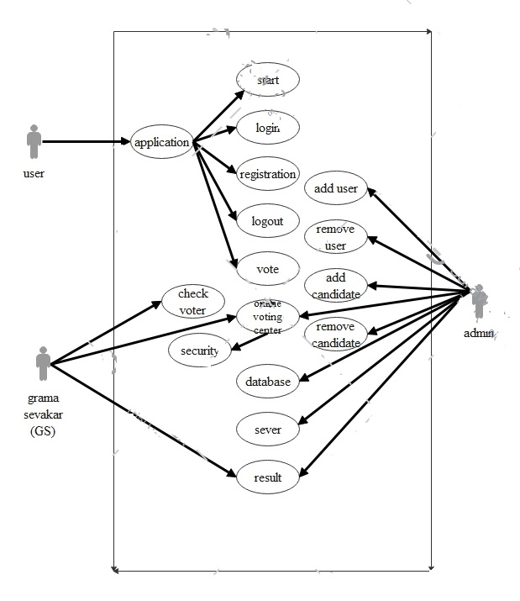

# References

1. Electronic voting system by Afolabi B. Oluwagbenga (2014)
2. Secure online voting system by Michael Chinwuba (oct,21, 2009)
3. Nigeria 2015: analysis of election issues and future prospects by Jon Lunn & denial harari (19 january, 2015)
4. Project report on online voting by Nandasaba Wilson (July 28, 2012)